Title（Verdana 16pt bold）
―Subtitle（Verdana 14pt bold）―
(empty line)
Kisoken Taro（Verdana 12pt bold）
Graduate Student, Kisoken University（Verdana 12pt bold）
(empty line)
This is the template for the Reports of 2023 FFLER SIG.
（Write the most important point of the article up to 50 words）

Abstract
Start writing abstract from here. Abstract must be no longer than 250 words. Choose three keywords that are most relevant to your paper. Use Times New Roman for the article body and Verdana for the section headings. The font size should be 10.5 for all elements of the paper except the article body appearing in 12. For the indentation format, follow this template. For more guidelines other than what is specified in this template, see APA 7th.
(empty line)
Keywords: L2 Speaking, Task Complexity, Attention Orientation
（empty line）
(empty line)
(empty line)
- Major Headings
Section headings are Verdana, font size 10.5, and boldface. They are aligned with the left margin with the first letters capitalized and the rest of the heading in lower case.
(empty line)
  - Sub headings
Sub-headings appear like major headings, except the first letter of the first word is capitalized and all the other words are not capitalized.
(empty line)
    - Sub-sub headings
Sub-sub-headings appear like sub-headings, except they are in italics. No more than three levels of headings should be used.
(empty line)
（Go to the next page）
Figure 1（The figure number should appear above the figure title in bold and flush left, not centered）
Write the figure title in italic below the figure number (Flush left, not centered)
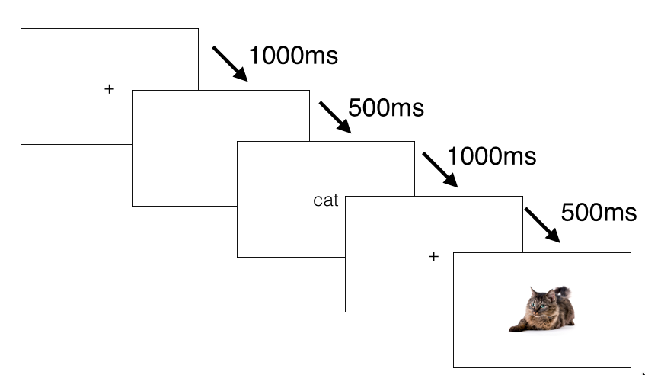
Note. The figure notes should be flush left. The image portion of the figure should also be flush left. The font should be Verdana for all elements of the figure including the number, the title, and the notes. For the image portion, a simple sans serif font (e.g., Arial, Calibri, and Lucida Sans) is acceptable. For more guidelines on formatting figures, see Sections 7.22–7.36 in APA 7th (pp. 225–250).
(empty line)
Table 1（The table number should appear above the table title in bold and flush left, not centered）
Write the table title in italic below the table number (Flush left, not centered)
Variable | n | M | SD | 95% CI
Variable 1 | 200 | 50.13 | 10.12 | [47.21, 51.34]
Variable 2 | 200 | 50.32 | 10.21 | [47.91, 51.34]
Variable 3 | 203 | 50.21 | 10.31 | [47.31, 52.51]
Variable 4 | 202 | 50.21 | 10.45 | [46.21, 54.35]
Note. The table notes should be flush left. The table body should also be flush left. The font should be Verdana for all elements of the table including the number, the title, and the notes. For the table body, a simple sans serif font (e.g., Arial, Calibri, and Lucida Sans) is acceptable. For more guidelines on formatting figures, see Sections 7.8–7.21 (pp. 199–224) in APA 7th.
(empty line)
（If sections begin right after tables or figures, add another empty line）
Note
- Do not use footnotes. Use endnotes.

Acknowledgements
Do not write acknowledgements to the SIG members and the editorial committee members.
References (in bold, centered. For more guidelines, see APA 7th.)
Lacouture, Y., & Cousineau, D. (2008). How to use MATLAB to fit the ex-Gaussian and other probability functions to a distribution of response times. Tutorials in Quantitative Methods for Psychology, 4(1), 35–45. http://www.tqmp.org/Content/vol04-1/p035/p035.pdf
Jiang, N. (2012). Conducting reaction time research in second language studies. Routledge.
Miller, K., Lindgren, E., & Sullivan, K. (2008). The psycholinguistic dimension in second language writing: Opportunities for research and pedagogy using computer keystroke logging. TESOL Quarterly, 42(3), 433–454. https://doi.org/10.1002/j.1545-7249.2008.tb00140.x

Author Information
Taro KISOKEN：Graduate Student, Kisoken University. He is a part-time lecturer at Kisoken Women’s College. His research interests are foreign language teaching, reading in a foreign language, and vocabulary instruction. He is a student member of the Japan Association for Language Education and Technology (Write your information following this sample).
Optional: Insert your photo (black and white) here.

Appendix
We strongly recommend that the authors include materials from the studies in the Appendix, and provide public, free access to the complete analysis code as well as raw data, for example, by saving them on a free, open platform such as OSF. However, care should be taken to ensure the confidentiality and to follow a code of research ethics.

